ScotRail 2025 Performance Audit: A Data-Driven Analysis of Delay Attribution
Project Objective
The goal of this project was to clean and analyse ScotRail 2025 performance data to identify the causes of rail delays and determine organizational accountability. Using data from the Office of Rail and Road (ORR), raw periodic statistics were transformed into a structured format to uncover performance trends and primary drivers of delay minutes.

The Dataset
The analysis utilized Table 3184 (https://dataportal.orr.gov.uk/statistics/performance/passenger-rail-performance/table-3184-delay-minutes-by-operator-and-cause-periodic/), which provides periodic delay minutes by operator and cause. The raw data was initially in a "wide" format, with multiple columns representing various delay categories, necessitating reshaping for effective analysis.

Technical Workflow
- Data Cleaning & Standardization: The dataset was filtered to isolate ScotRail’s 2024–2025 financial year data. Column headers were standardized by converting them to lowercase and removing parentheses.
- Feature Engineering: Numeric values for the "Period" (e.g., Period 04) and the "Financial Year" string were extracted from raw time-period text to enable chronological sorting.
- Data Reshaping (Unpivoting): The melt function was used to transform the data from a wide format into a long format. This created a single delay_cause column and a minute’s column, making the data compatible with categorical plotting libraries like Seaborn.
- Responsibility Mapping: A custom Python function categorized specific delay causes into three high-level buckets: Network Rail (Infrastructure), ScotRail (Operational), and External / Other Operators.

Key Insights
- Primary Delay Drivers: The leading cause of delays was Network Management Other, totaling 244,642 minutes, followed by Non-Track Assets at 218,478 minutes.
- Organizational Accountability: Infrastructure issues managed by Network Rail accounted for the largest share of delay minutes (886,905.9), while ScotRail’s own operational issues contributed 636,614.3 minutes.
- Temporal Trends: Performance data for the 2024–2025 period highlighted a significant spike in delays during Period 08, where total delay minutes peaked at over 100,000.

Visualizations
- ScotRail: Total Delay Minutes by Category (2025): A bar chart displaying categories contributing to total delay minutes, highlighting the dominance of infrastructure-related issues.
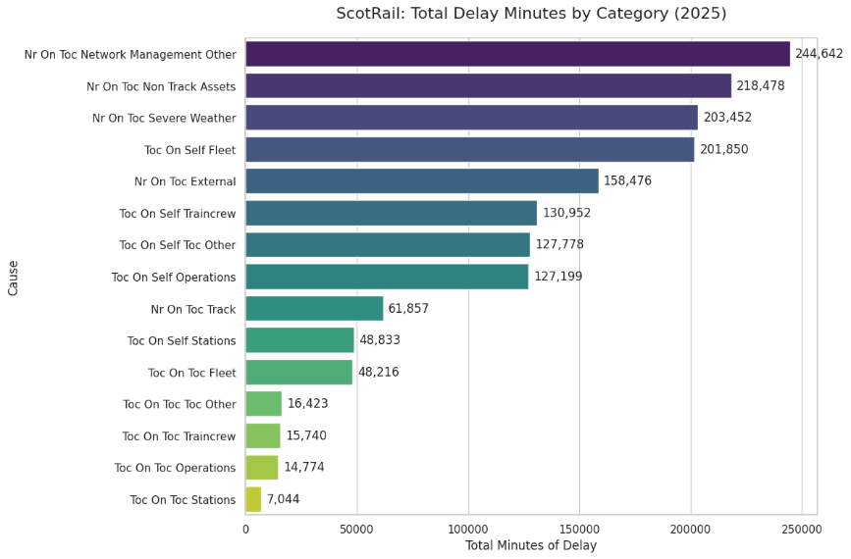
- High-Level Responsibility for Delays (2025): A comparison of total delay minutes attributed to Network Rail vs. ScotRail operations.
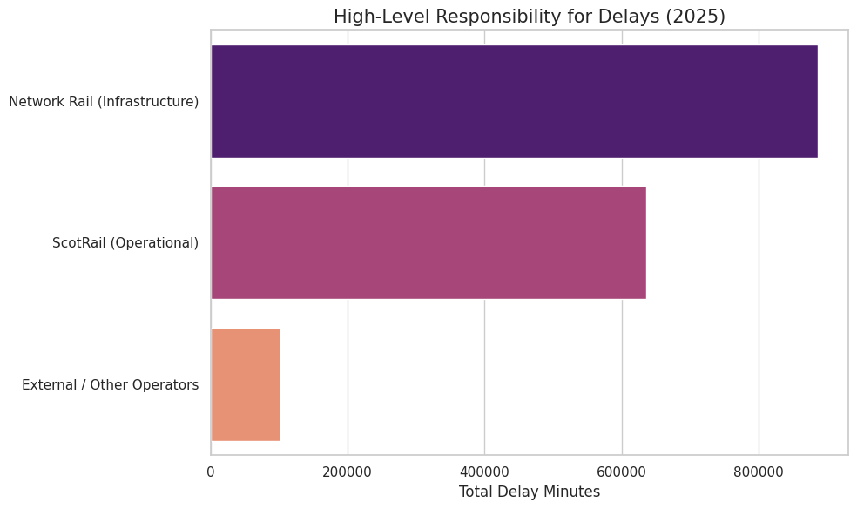
- Total ScotRail Delay Minutes: 2025 Trend: A chronological line chart showing performance volatility throughout the financial year, including the major spike in late 2024.
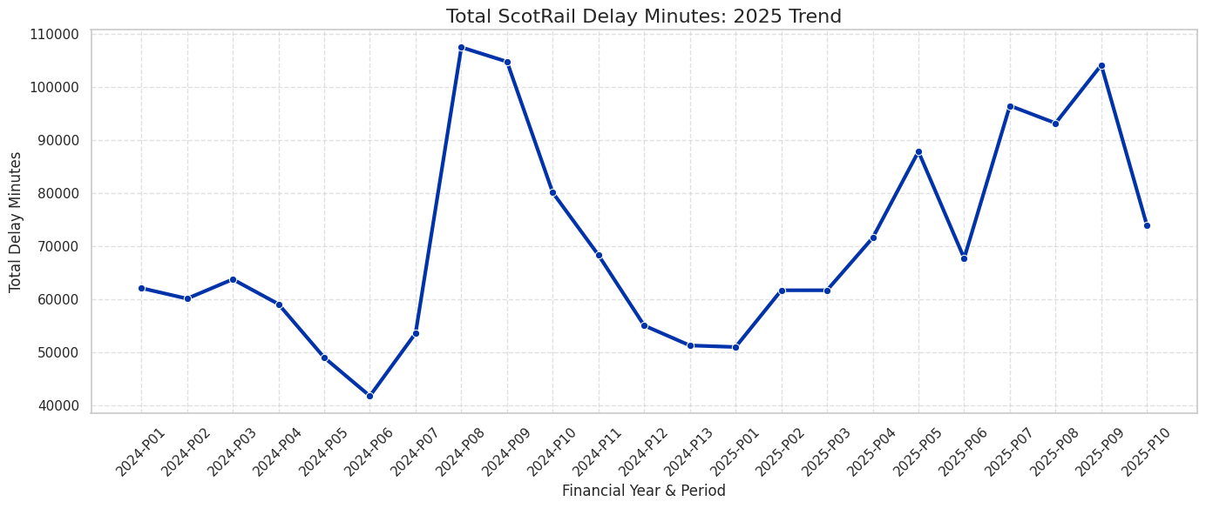
- The 5 Biggest Problems for ScotRail in 2025: A focused breakdown of the top five specific delay causes.
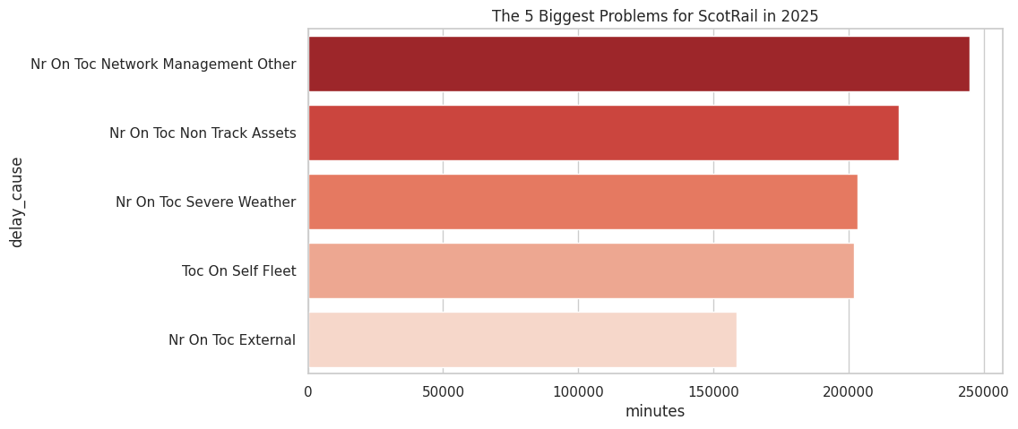

Tools & Libraries
- Python: Main language for data processing.
- Pandas: Data cleaning, unpivoting, and aggregation.
- Matplotlib & Seaborn: Data visualization.
- Regular Expressions: Feature extraction from text strings.

